

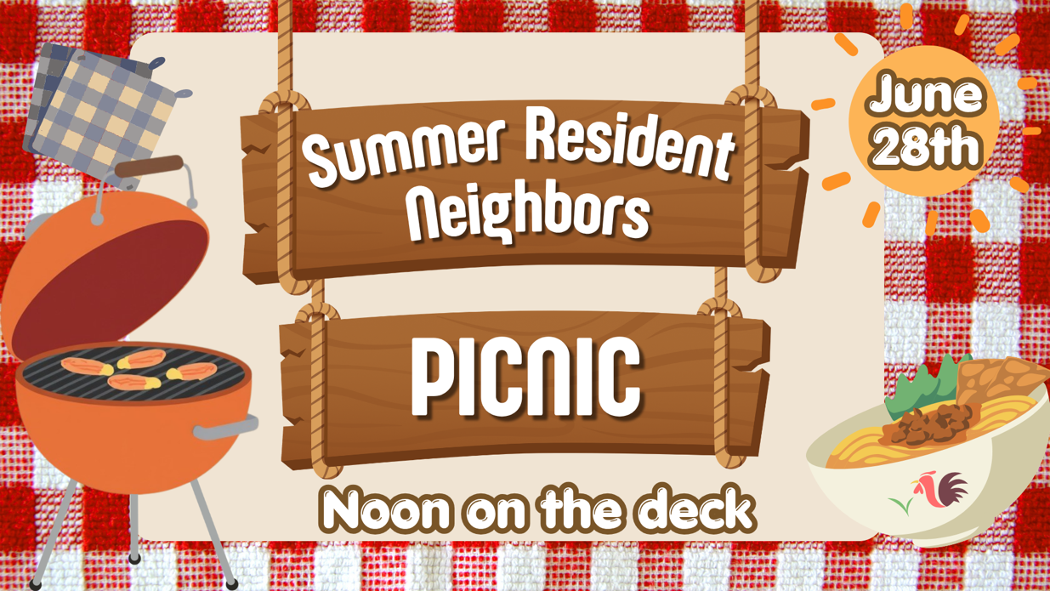

Hello!

We hope you will join us for a Summer Residents’ Picnic on Sunday, June 28, noon-2pm following the second Gathering at Genesis Petoskey. We’ll have grilled chicken and delicious vegetables, make new connections, and learn about opportunities to engage with Genesis Church throughout the summer.

Come enjoy good food, meaningful conversation, and a chance to get to know others who spend part of their year in our community. We will also introduce "Summer Suppers” at this picnic.

Everyone is welcome: individuals, couples, families, children, and guests of all ages. You may have been attending Genesis for years or you may be brand new.

Love bringing a dish to pass? Feel free to bring a salad or dessert!

Please RSVP HERE by June 24 so we can plan accordingly.

